Social media toolkit
National Catholic Health Care Week
The annual National Catholic Health Care Week will take place from Sunday, February 1 to Saturday, February 7, 2026.
We are asking organizations across the country to recognize the week through their social media platforms.
National Catholic Health Care Week is a week to:
- Amplify our shared mission through a consistent, strong collective voice
- Showcase our role, value, and impact in local communities and across the country
- Demonstrate that we are people-centred, expert contributors to the health system
- Engage our stakeholders in conversation about Catholic health care
Why February?
National Catholic Health Care Week leads into The World Day of the Sick on February 11, a Catholic day of observance established by Pope John Paul II to encourage prayers and reflections for those who are ill and for all those who care for them.
Open Hearts, Healing, Hope
This year’s theme Open Hearts, Healing, Hope reflects the profound belief that healing is communal. It emphasizes the ways in which we are bound together by our shared humanity, and how compassion, justice, and solidarity guide our work to serve all people, especially those who are vulnerable or marginalized. Inspired by Catholic social teaching, the theme invites us to reflect on how our daily actions, decisions, and relationships contribute to a health system and a society where everyone belongs. It calls us to recognize the dignity of each person, to listen deeply to the needs of our communities, and to foster participation, inclusion, and hope—principles rooted in our Catholic tradition and lived every day through the care we provide. In a world marked by division and uncertainty, Open Hearts, Healing, Hope celebrates the strength that comes from walking together and building relationships grounded in respect, compassion, and justice.
Catholic Health Care
During National Catholic Health Care Week, we invite you to reflect on and share your organization’s story. As Catholic health organizations across Canada, we are united in a 400-year healing mission and are inspired by a calling to care for all with compassion and humanity—body, mind and spirit. We are driven to improve health care for all Canadians, especially those at greatest risk, as innovators, advocates and strong partners across our health care system. We are driven to make the world a better place, where everyone finds belonging, dignity and worth. In this, we reach out and take action with others to mend and bridge gaps, open doors and create the conditions for a society where all are seen and heard.

Social Media Posts and Hashtag
Please promote National Catholic Health Care Week on your social media platforms and use #catholichealthcareweek wherever possible during the Week.
We ask you participate in this important week of recognition for our teams and our mission. Four branded posts are provided—with headings reflecting this year’s theme. These posts incorporate an image and message for you to build on. We encourage you to amplify these posts with examples of your own organization’s stories and commitment to creating care environments and community outreach with compassion and connection to foster healing and hope. Please use the hashtag #catholichealthcareweek. The link to National Health Care Week on the CHAC website is https://www.chac.ca/en/national-catholic-health-care-week/.
Images for posts are available here for your use during week. Suggested quotes and messages are provided for each post as possible lead-in for your own organizational facts, stories or messages.
Additional quotes and key messages are provided on the following page.
Theme | Posts | Possible Quotes and Messages
NCHCW text which can be used for all posts. |  | Catholic health organizations across Canada are united in a 400-year mission of hope, working to foster caring communities and support the well-being of all—body, mind and soul.
Open, Hearts, Healing, Hope | 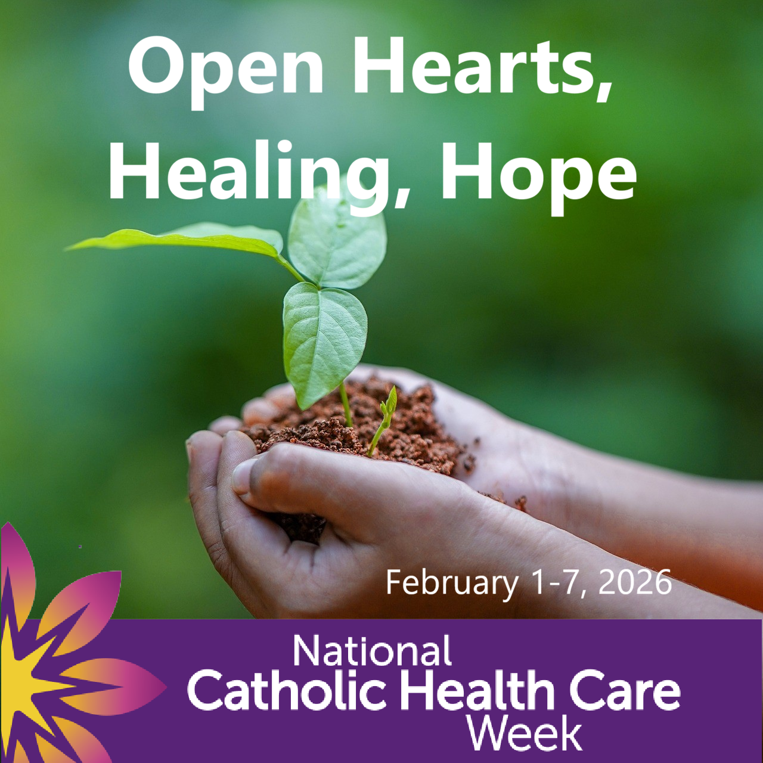 | - Open hearts nurture healing and connection—reminding us that when care is rooted in compassion, hope can take hold and grow.  - “We belong to each other.” (St. Teresa of Calcutta)  - “Even the smallest act of care carries the power to restore hope.” (Viktor Frankl)
Open Hearts | 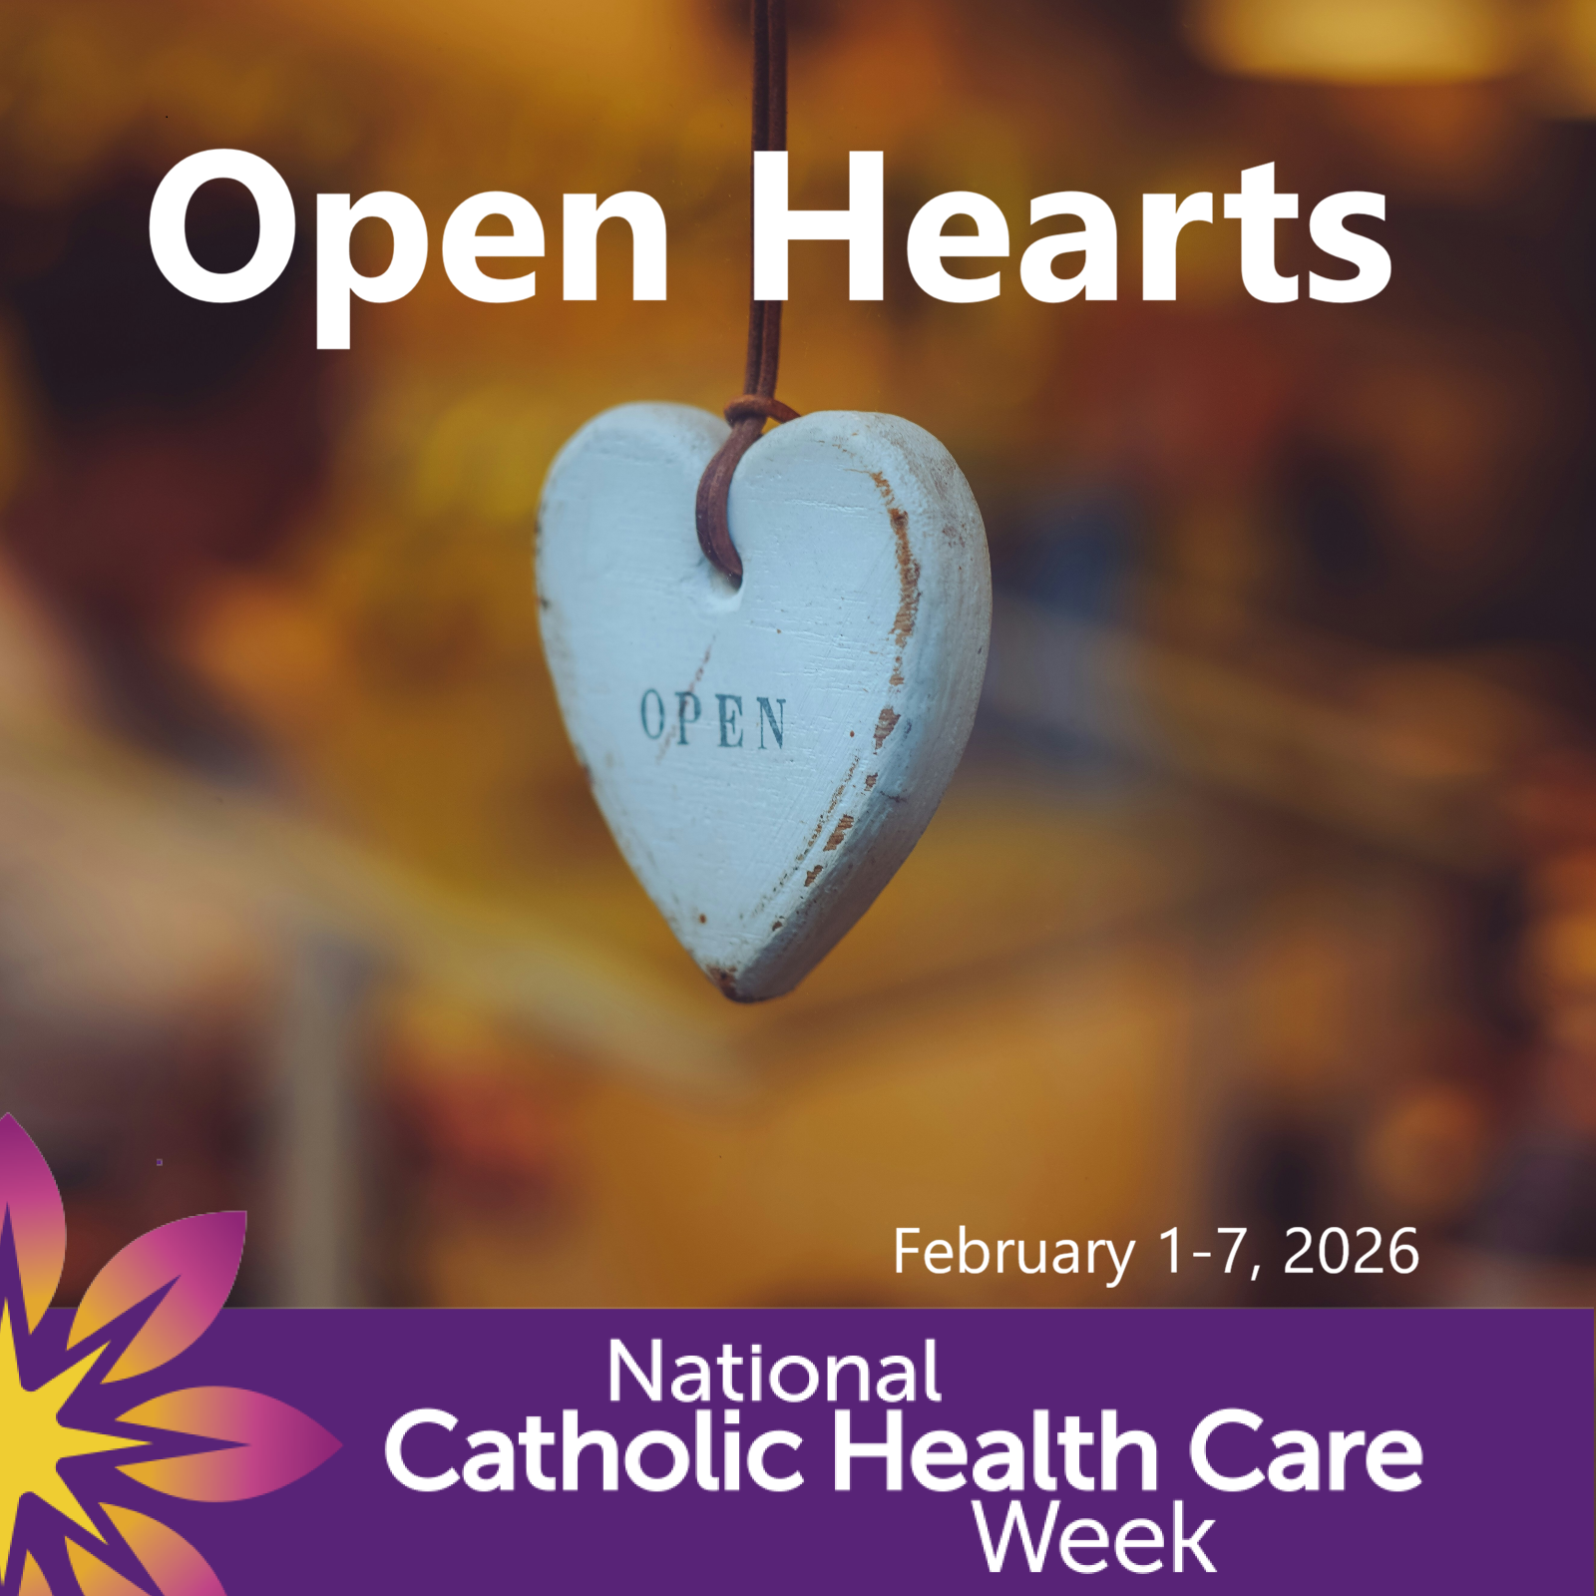 | - Open hearts invite us to see one another fully and to create spaces where everyone belongs  - “Compassion is the radicalism of our time.” (Dalai Lama)  - “When we open our hearts, we discover that we are more alike than different” (Thích Nhất Hạnh)
Healing | 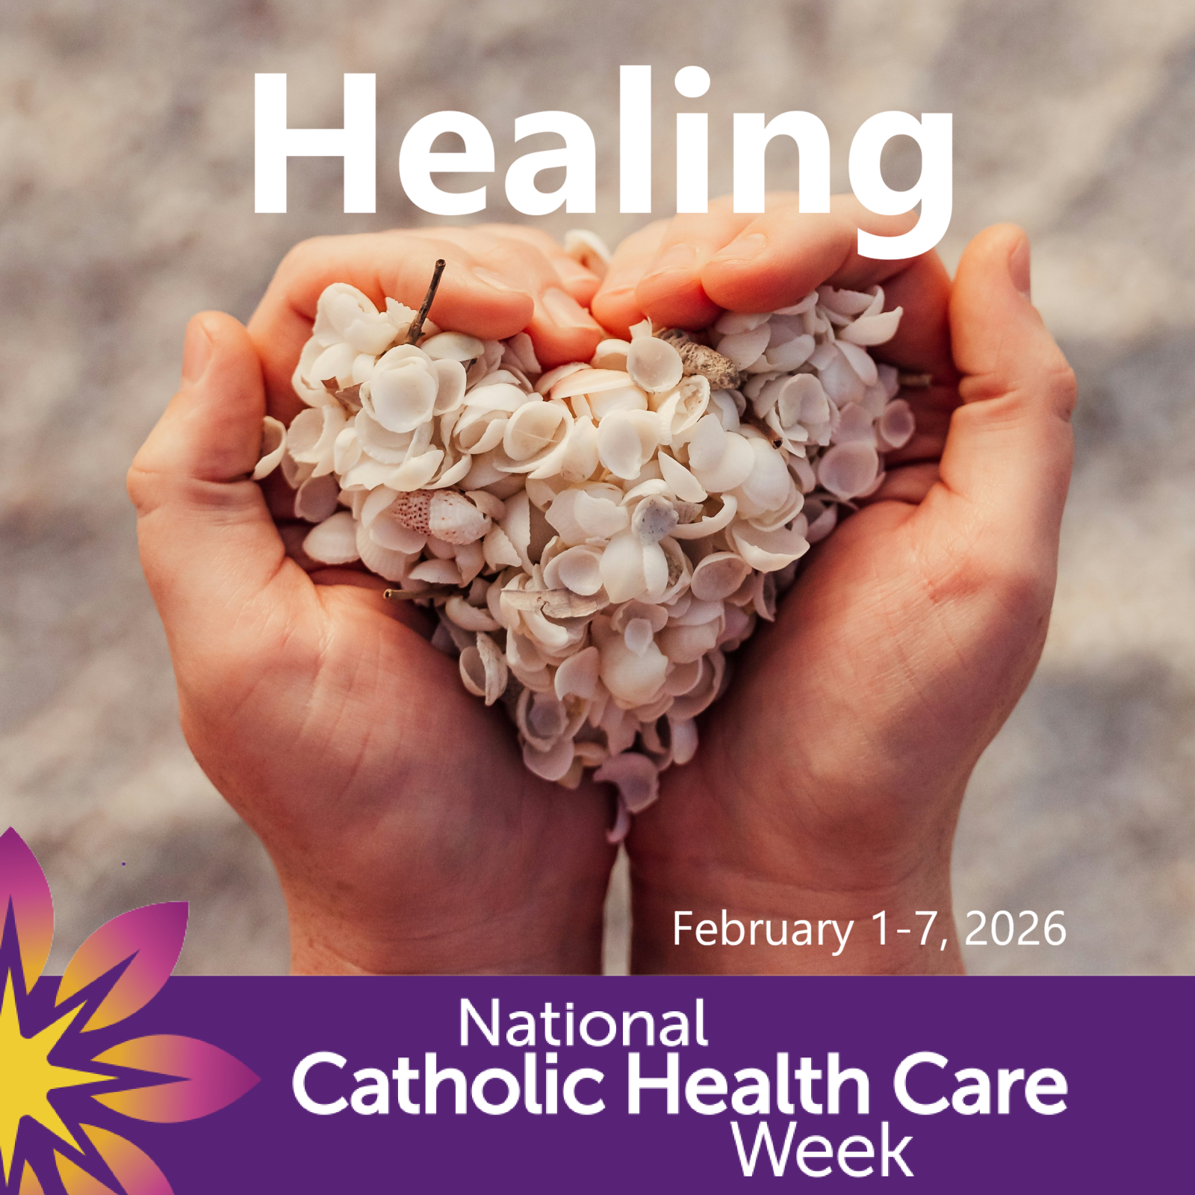 | - True healing is communal, unfolding through presence, understanding, and shared care  - A community that listens is a community that heals.  - “Our stories are our medicine.” (Richard Wagamese)  - “The deepest need of the human heart is to be seen.” (Archbishop Desmond Tutu)
Hope | 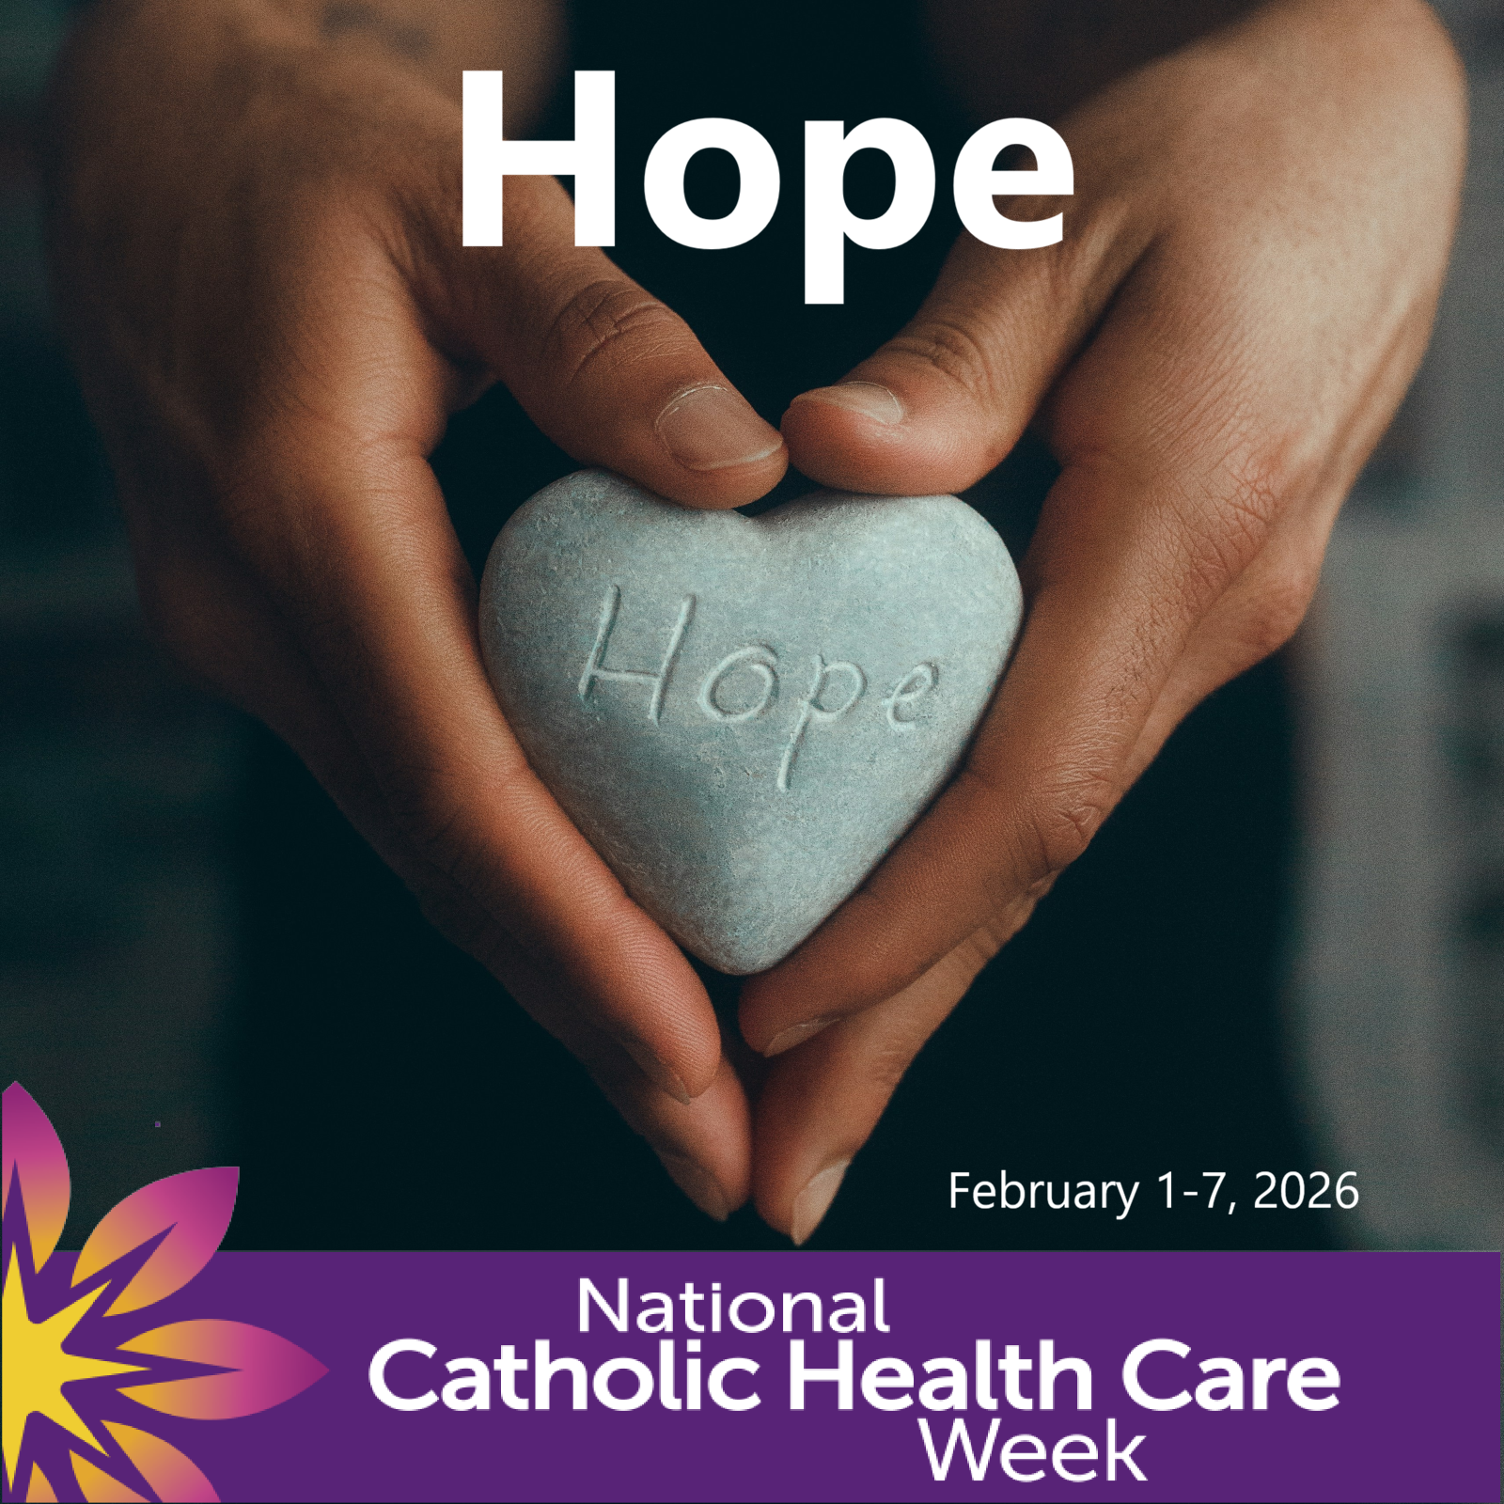 | - Hope is sustained by small acts of care that open the door to healing and change.  - “Where there is care, there is hope.” (Pope Francis)  - “Hope is rooted in relationship—in the belief that we do not face the future alone.” (Parker J. Palmer)  - “Hope is not just a feeling—it is a responsibility.” (Chief Wilton Littlechild)
Additional Messages and Quotations
- Open hearts create space for dignity, compassion, and belonging—reminding us that care begins with how we listen, welcome, and respond to one another.
- Healing is more than recovery—it is the work of restoring wholeness through care, connection, and compassion.
- Healing happens in relationship, when care honours the whole person and the community around them.
- With open hearts, healing and connection can grow—rooted in care, compassion, and our shared humanity.
- When we hold care gently, with open hearts, healing and connection can grow in ways that sustain us all.
- “We are called to be signs of hope for those of our brothers and sisters who experience hardships of any kind. Care given to them is a hymn to human dignity, a song of hope that calls for the choral participation of society as a whole.” (Pope Francis)
- “The touch of compassion was the first medicine.” (Pope Leo XIV)
- “Love is above all a way of looking at life and a way of living--through your work, your efforts to change unjust social structures or your simple, heartfelt gesture of closeness and support.” (Pope Leo XIV)
- “The greatest gift we can give one another is our presence.” (Thích Nhất Hạnh)
- “Being heard is so close to being loved that for the average person, they are almost indistinguishable.” (David Augsburger)
- “Be curious, be open, be grateful for the stories others bring; they expand the borders of our own heart.” (Parker J. Palmer)
- “Go quiety, be gentle and show your heart in everything you do.” (Richard Wagamese)
- “Hope is not a feeling; it is a practice.” (Margaret Wheatley)
Resources
Several resources are available on the CHAC website (chac.ca) and the National Catholic Health Care Week web page including:
- A video on Catholic Health Care (less than three minutes)
- Daily Reflections and Prayers
- The Courageous Gift and facts on Catholic health care in Canada
Contact
John Ruetz
President and CEO, Catholic Health Alliance of Canada
e: john.ruetz@chac.ca • p: (613) 567-1200

