Social media toolkit
National Catholic Health Care Week
The fifth annual National Catholic Health Care Week will take place from Sunday, February 4 to Saturday, February 10, 2024.
We are asking organizations across the country to recognize the Week through their social media platforms.
National Catholic Health Care Week is a Week to:
- Amplify our shared mission through a consistent, strong collective voice
- Showcase our role, value, and impact in local communities and across the country
- Demonstrate that we are people-focused, expert contributors to the health system
- Engage our stakeholders in conversation about Catholic health care
Why February?
National Catholic Health Care Week leads into The World Day of the Sick on February 11, a Catholic day of observance established by Pope John Paul II to encourage prayers and reflections for those who are ill and for all those who care for them.
Building Bridges
This year’s theme speaks to the gift of Catholic health as a sign of hope in the world and offers each person in their journey to care for themselves or others some words of blessing and hope.
As Catholic health, we strive each day to be a compassionate presence in a broken world, to work together with those we serve, caregivers, and our communities and partners to create safe, welcoming environments where all are seen and heard and can find hope. As innovators and advocates, we contribute to and help shape an ever-evolving health system, drawing on our Catholic values, and a legacy of innovation and ethical reflection.
This year’s theme encourages and inspires us all to nurture hope through our individual and organizational efforts to foster connections, belonging, healing, wellbeing and purpose.
This begins in acknowledging the deep and lingering scars from the pandemic in our health system and society—high levels of loneliness, isolation, chronic illness, fatigue, stress, mental illness and addiction, and economic uncertainty.
This Week is an opportunity to reflect on this mission of hope and to share stories about how we work with many partners—in our Catholic community, our health system and beyond—to foster hope and healing in ourselves, our communities and our society: to make life-giving connections, welcome each other in community, foster healing and wellness—body, mind and soul—and find purpose and meaning in our calling and our circumstances.
The Courageous Gift of Catholic Health Care
During National Catholic Health Care Week, we invite you to reflect on and share the story of the courageous gift of Catholic health care. As Catholic health organizations across Canada, we are united in a 400-year healing mission and are inspired by a calling to care for all with compassion and humanity—body, mind and spirit. We are driven to improve health care for all Canadians, especially those at greatest risk, as innovators, advocates and strong partners across our health care system.
The Week is an invitation to learn more about the role, value and impact of Catholic health care in Canada and to be vocal, informed supporters of Catholic health care and the healing ministry of Jesus in Canada. The Courageous Gift statements—inspired to serve, together in care, passion for justice, and courage to lead—express the heart of our work, rooted in the Gospel and the legacy of our founding congregations. This year’s theme of Signs of Hope focuses on our calling and inspiration to serve.
Social Media Posts and Hashtag
Please promote National Catholic Health Care Week on your social media platforms and use #catholichealthcareweek wherever possible during the Week.
You are welcome to use the attached posts—designed for Instagram, Twitter, and Facebook—or to create your own. Posts along with sample captions are below. Please use the hashtag #catholichealthcareweek. The link to National Health Care Week on the CHAC website is https://www.chac.ca/en/national-catholic-health-care-week/. Images for posts are available here. Suggested topics for the types of stories (from the newsrooms of your own organization or in your community) that you may wish to share are also provided.
Day | Post | Sample caption | Ideas to feature
Monday,  February 5  Connection | 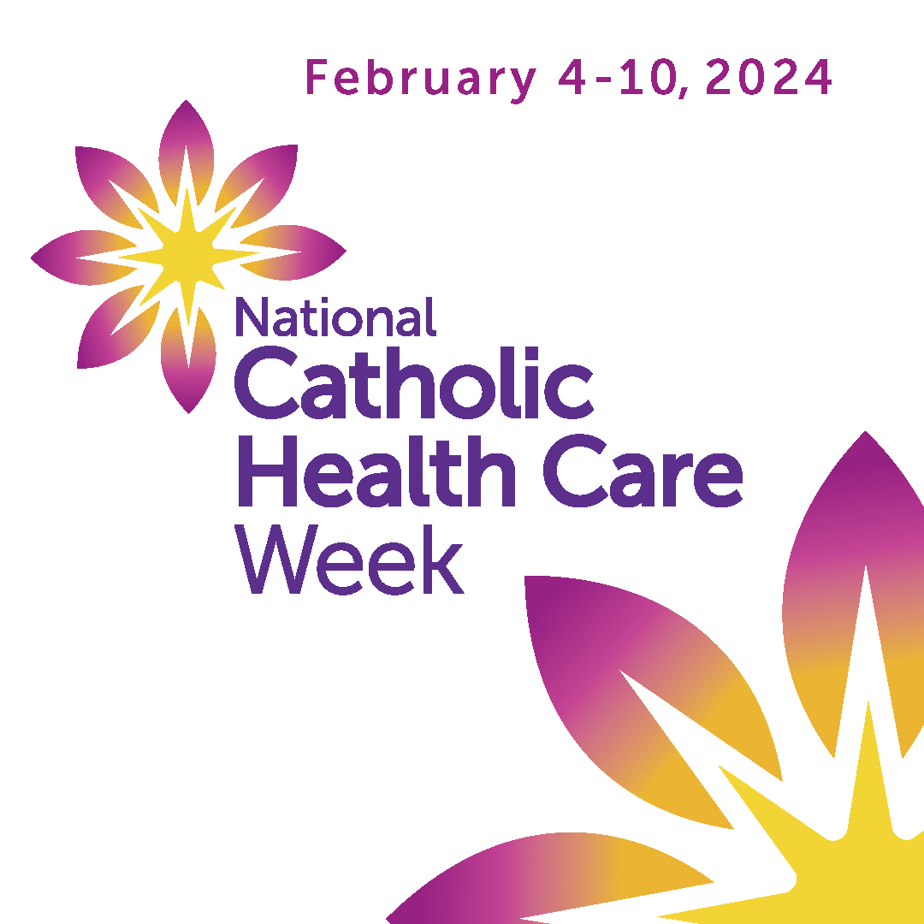 | As Catholic organizations across Canada, we work with our communities and partners to foster hope and human connection—to achieve a Canadian society that reaches out to very person who is suffering from illness, stigma, poverty, loneliness.  #catholichealthcareweek  <link to National Catholic Health Care Week on the CHAC website, or insert your call to action, link to story on your website or ask a question to prompt engagement> | Programs to address loneliness and isolation; collaborative work to reach out or respond to social issues; connections with community.
Tuesday,  February 6  Belonging | 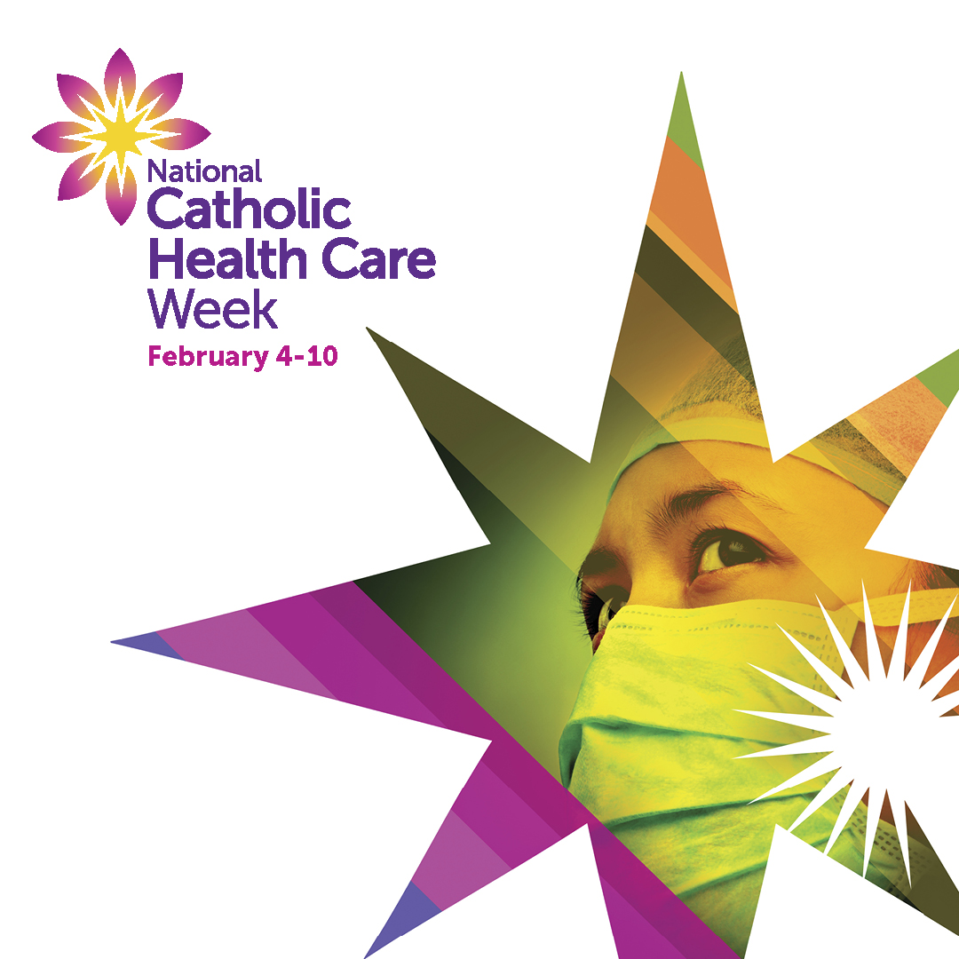 | Across Canada, Catholic health works with many partners to bring together the health and social supports needed to address complex system challenges and help Canadians live and age well in community.  #catholichealthcareweek  <link to National Catholic Health Care Week on the CHAC website, or insert your call to action, link to story on your website or ask a question to prompt engagement> | Aging in place; bridging health and social supports; safe care and work environments supporting diversity and inclusion.
Wednesday, February 7  Healing | 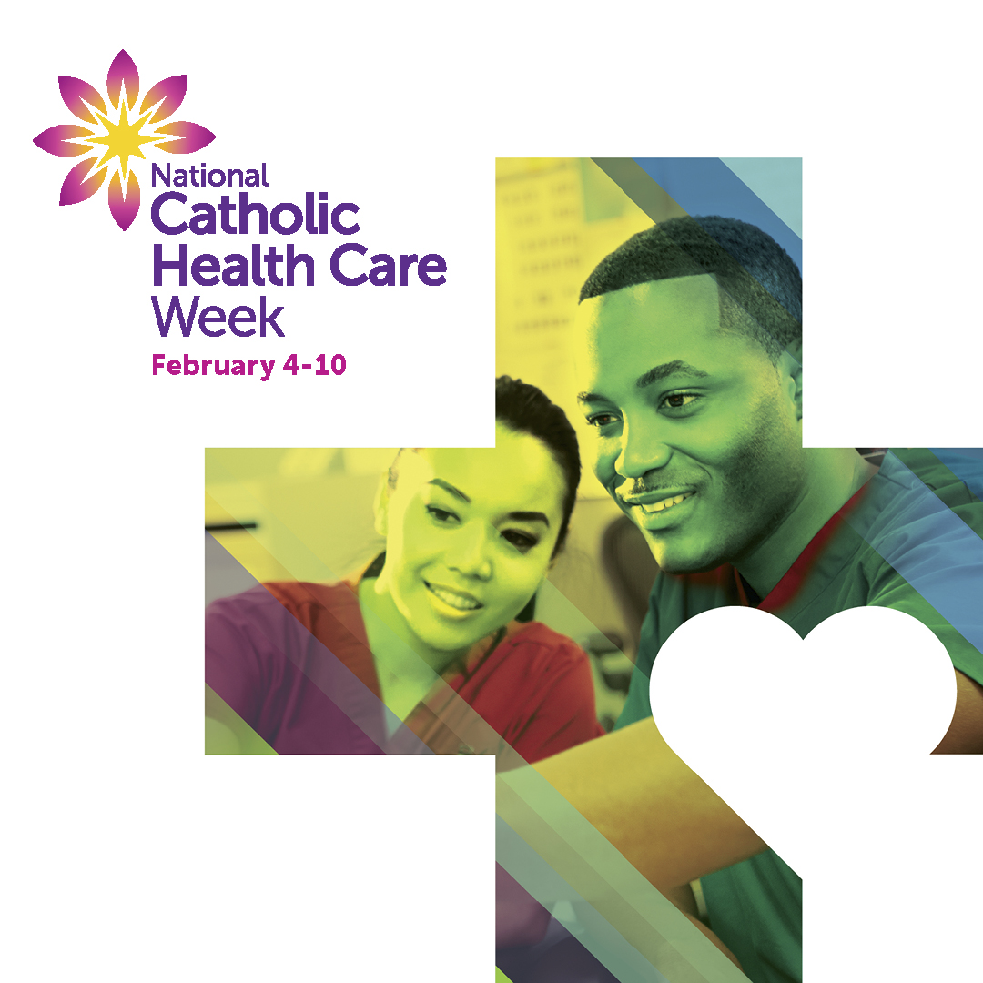 | In all we do, we work to promote hope, dignity and relationships of trust, as we learn from each other and walk together on the healing journey.  #catholichealthcareweek  <link to National Catholic Health Care Week on the CHAC website, or insert your call to action, link to story on your website or ask a question to prompt engagement> | Commitment to care for the whole person; truth and reconciliation efforts; creating healthy, welcoming care environments.
Thursday, February 8  Wellbeing | 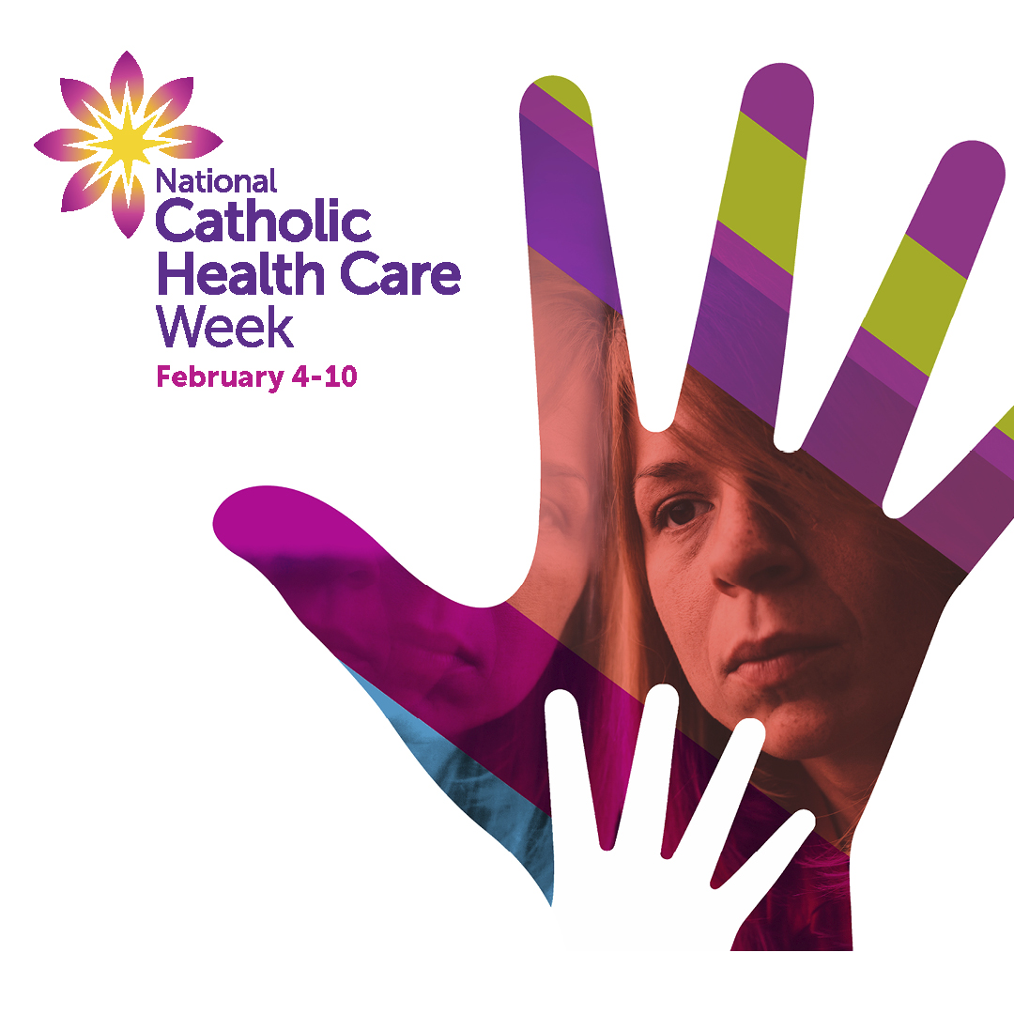 | Catholic health organizations across Canada are united in a 400-year mission of hope, working to foster caring communities and support the well-being of all—body, mind and soul.  #catholichealthcareweek  <link to National Catholic Health Care Week on the CHAC website, or insert your call to action, link to story on your website or ask a question to prompt engagement> | Focus on health promotion, community- based care and prevention, integration of mental health. Promoting self- care and balance at work.
Friday,  February 9  Purpose | 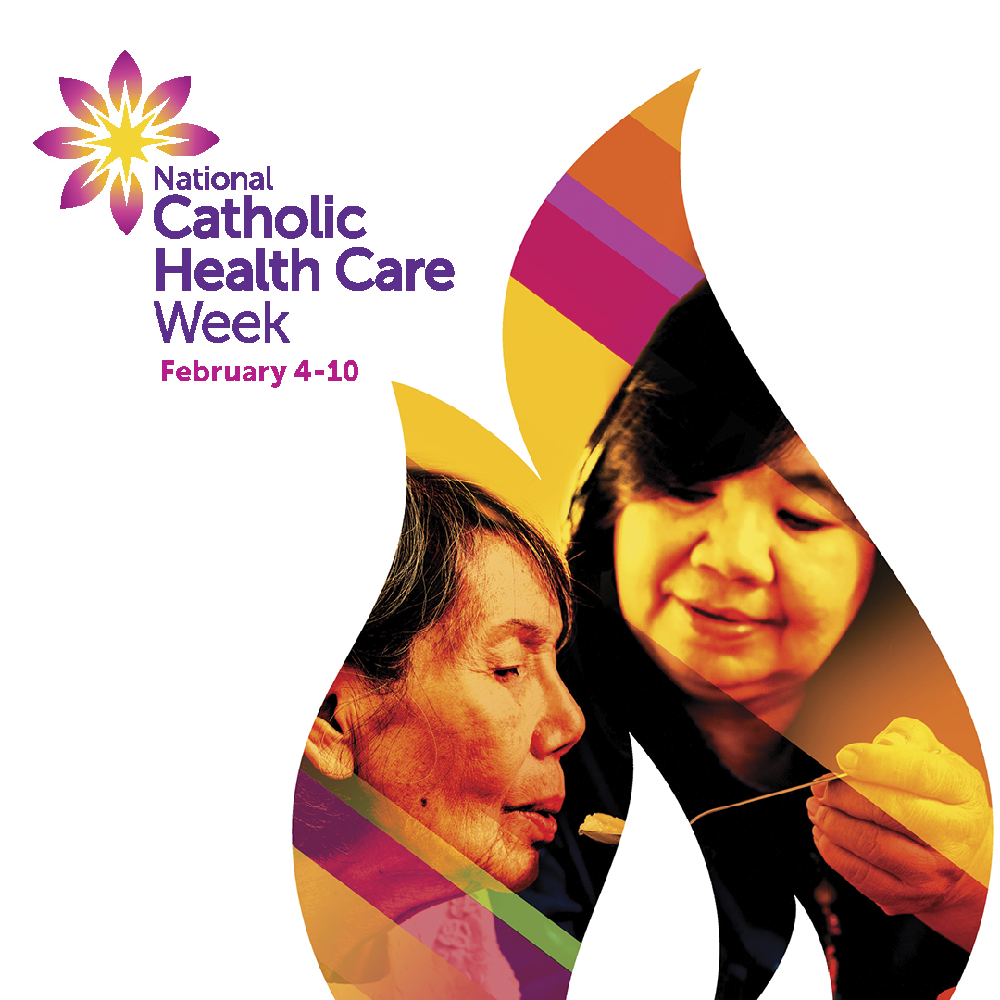 | We are inspired by the hope and courage we witness each day. We see our work as a calling—a profound sense of purpose and a privilege to serve others through moments of life’s joy and challenges.  #catholichealthcareweek  <link to National Catholic Health Care Week on the CHAC website, or insert your call to action, link to story on your website or ask a question to prompt engagement> | Celebration of mission and culture; charitable contributions; stories of going the extra mile to bring joy or hope.
Resources
Several resources are available on the CHAC website (chac.ca) including:
- A video on Catholic Health Care (less than three minutes)
- Daily Reflections and Prayers
- The The Courageous Gift with the four pillars
- Facts on Catholic health care in Canada
- National Catholic Health Care Week customizable template
Contact
John Ruetz
President and CEO, Catholic Health Alliance of Canada
e: john.ruetz@chac.ca • p: (613) 567-1200

